*- for immediate release -*

Press release

**MIKRO 2.0 and MIKRO 2.0 R**Hettich Group launches next-generation microcentrifuges

Tuttlingen, May 05, 2025

**Andreas Hettich GmbH launches the new MIKRO 2.0 and MIKRO 2.0 R microcentrifuges – easy to operate, space-saving and equipped with NFC safety technology for modern laboratories.**

Hettich presents the new MIKRO 2.0 and MIKRO 2.0 R microcentrifuges – compact, user-friendly, and equipped with modern NFC technology for maximum safety in the lab.

With the MIKRO 2.0, Hettich introduces a new generation of compact microcentrifuges designed to meet the practical demands of everyday lab work. These devices combine efficient operation with a minimal footprint and reliable safety features. The series is complemented by the MIKRO 2.0 R – a refrigerated version developed for temperature-sensitive sample applications.

“With the MIKRO 2.0, we are setting new standards in microcentrifugation,” says Dr. Peter Kunze, Director of Sales and Marketing at Andreas Hettich GmbH. “It’s user-focused interface, compact footprint and automatic rotor recognition via NFC align perfectly with the needs of today’s laboratories.”

Operation is straightforward, with a high-resolution LCD screen and precise control designed for logical, efficient navigation. At just 240 mm wide, the MIKRO 2.0 is among the slimmest devices in its class – ideal for labs with limited bench space.

For maximum safety, built-in NFC technology automatically identifies the inserted rotor and sets the permissible operating parameters. The quick-change rotor system allows for tool-free rotor exchange in seconds. A patented lid quick-release mechanism adds to ease of use and daily safety.

The MIKRO 2.0 is designed for maximum flexibility, supporting a wide range of sample formats – from 0.2 ml microliter tubes, cryovials, and PCR strips to 5 ml tubes. Up to eight custom programs can be saved and accessed directly via shortcut keys – ideal for routine workflows. With a maximum RCF of 25,212 and a temperature range of -20 °C to +40 °C (MIKRO 2.0 R), the system meets the demands of research, diagnostics, and routine analysis.

The launch of the MIKRO 2.0 | 2.0 R further strengthens Hettich’s role as an innovation leader in centrifugation. The company continues to develop smart, safe, and efficient technologies that make daily lab work noticeably easier.

-------------------------------------------------------------------------

Short version:  
**MIKRO 2.0 and MIKRO 2.0 R: Compact power for demanding microcentrifugation tasks**  
With the MIKRO 2.0 and MIKRO 2.0 R, Hettich introduces two new microcentrifuges designed for use in research, diagnostics, and routine labs. These compact devices combine precise handling with advanced safety features and an efficient footprint.

Both models feature a high-resolution LCD and push-turn control for fast navigation without extensive training. At just 240 mm wide, they are among the slimmest in their category – perfect for space-limited labs.

Built-in NFC technology automatically identifies the rotor and applies the correct operating parameters, reducing user error. The tool-free rotor quick-change system supports fast operation and easy cleaning.

The refrigerated MIKRO 2.0 R expands the application range with a temperature spectrum from -20 °C to +40 °C – ideal for sensitive samples. A flexible rotor range allows use with various sample types, from 0.2 ml microliter tubes and cryovials to PCR strips and 5 ml tubes.

**Media**

© Andreas Hettich GmbH

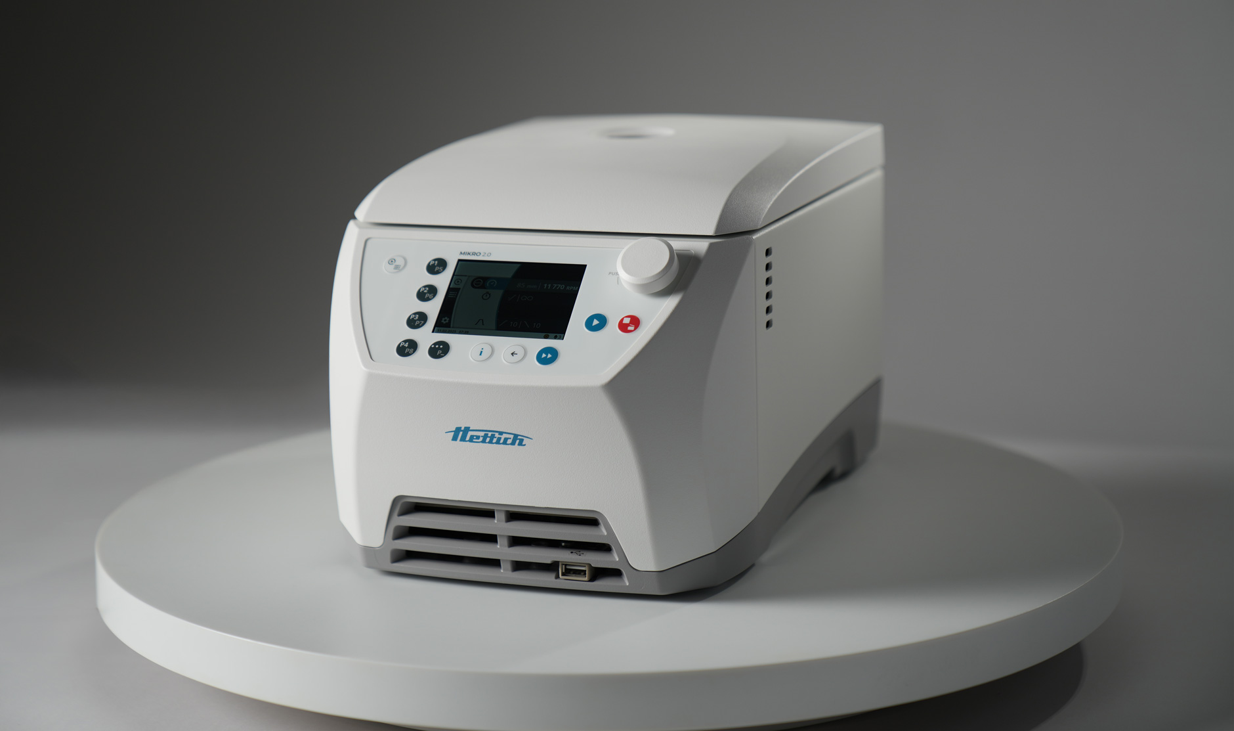  
Picture 1: Compact design meets modern aesthetics: The MIKRO 2.0 fits on any lab bench with just 240 mm of width.

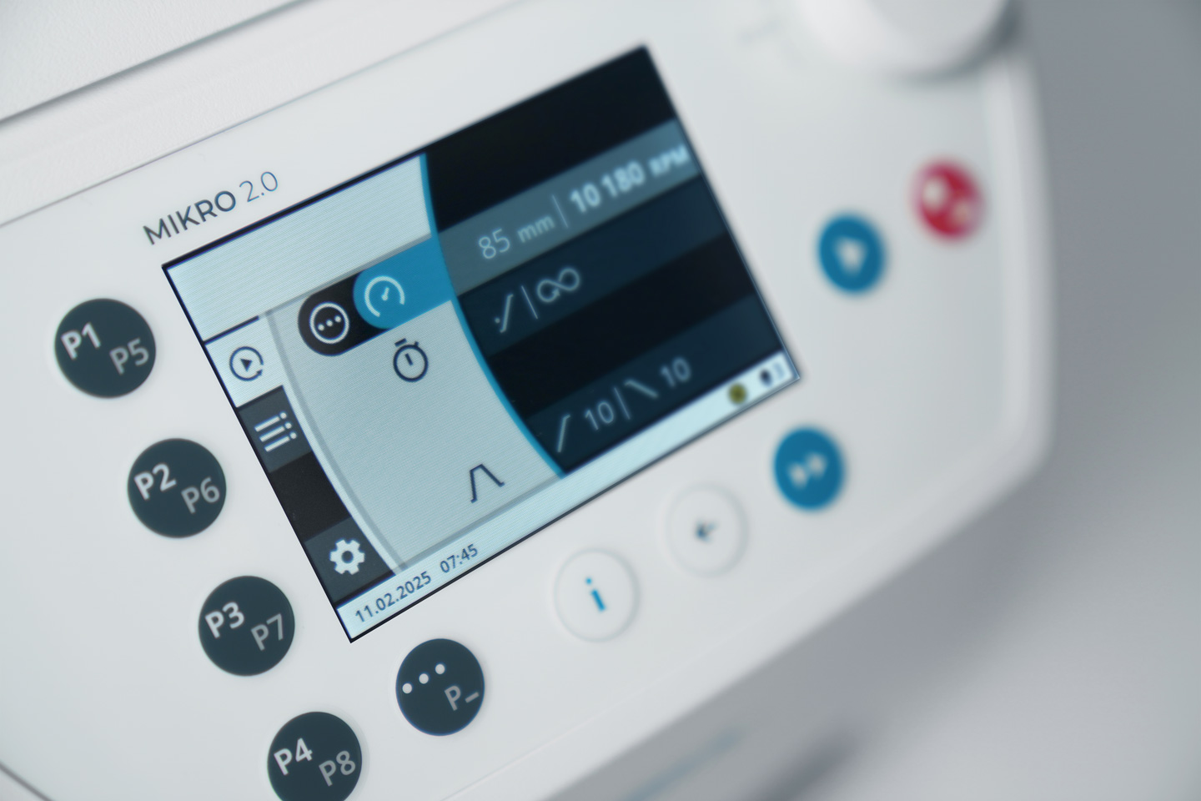Ein Bild, das Haushaltsgerät, medizinische Ausrüstung, Maschine, Im Haus enthält.

Picture 2+ 3: High-resolution LCD display and precise rotary push button enable efficient operation without extensive training.

Ein Bild, das Gerät, Küchengerät, Haushaltsgerät, Waschmaschine enthält.

Picture 4: Tool-free rotor exchange completed in seconds—for uninterrupted workflows and more time for what matters.

**Press contact:**Susanne Heizmann

Tel: +49 7461 705-1231

E-Mail: susanne.heizmann@hettichlab.com

**About Andreas Hettich GmbH**Andreas Hettich GmbH - is a leading global manufacturer of centrifuges and incubators, providing high-quality products for research labs, clinical labs, and medical facilities worldwide. With 120 years of experience and worldwide over 500 employees, Hettich is committed to developing innovative solutions that meet the evolving needs of the scientific community. All departments such as research, development and production are located at the headquarters in Tuttlingen, Germany.  
  
Further information at **www.hettichlab.com**