- for immediate release -
Press release

Management change at Andreas Hettich GmbH
- A new leadership team for a future-oriented Hettich Group

Tuttlingen, March 28, 2025

After 20 years of successful leadership by the Eberle family, the Hettich Group is setting the course for a forward-looking realignment. As of April 1, 2025, the company’s management team will be restructured to ensure long-term development and sustainable growth.

Mr. Ralf Ledda, a seasoned and accomplished executive, is taking over the leadership of the Hettich Group. With his extensive experience, including leadership roles at Auxilium GmbH, Alber GmbH, and as Senior Vice President at Invacare GmbH, he will play a pivotal role in driving the company’s future growth and development.

To broaden the company’s leadership structure, Mr. Leopold Frank, previously Technical Director, and Mr. Christoph Pabst, previously Commercial Director, will also join the executive management team on April 1, 2025. Together, this dynamic leadership team will create a strong foundation for the company’s continued expansion and sustainability.

The current Managing Directors, Klaus-Günter and Kristina Eberle, will continue to support the company operationally during a transition phase before assuming new roles as Chairman and Member of the Advisory Board, respectively.

This ensures that the company’s strategic direction remains in experienced hands and continues to benefit from the longstanding expertise and dedication of all involved.

“We are proud of what we have achieved together with our employees and look to the future with confidence. With Ralf Ledda, Leopold Frank, and Christoph Pabst, as well as the entire Hettich Group team, our company will continue on its successful path,” said Klaus-Günter Eberle.

The Hettich Group looks forward to this new chapter and extends its gratitude to all employees, customers, and partners for their trust and support.

Media
© Andreas Hettich GmbH

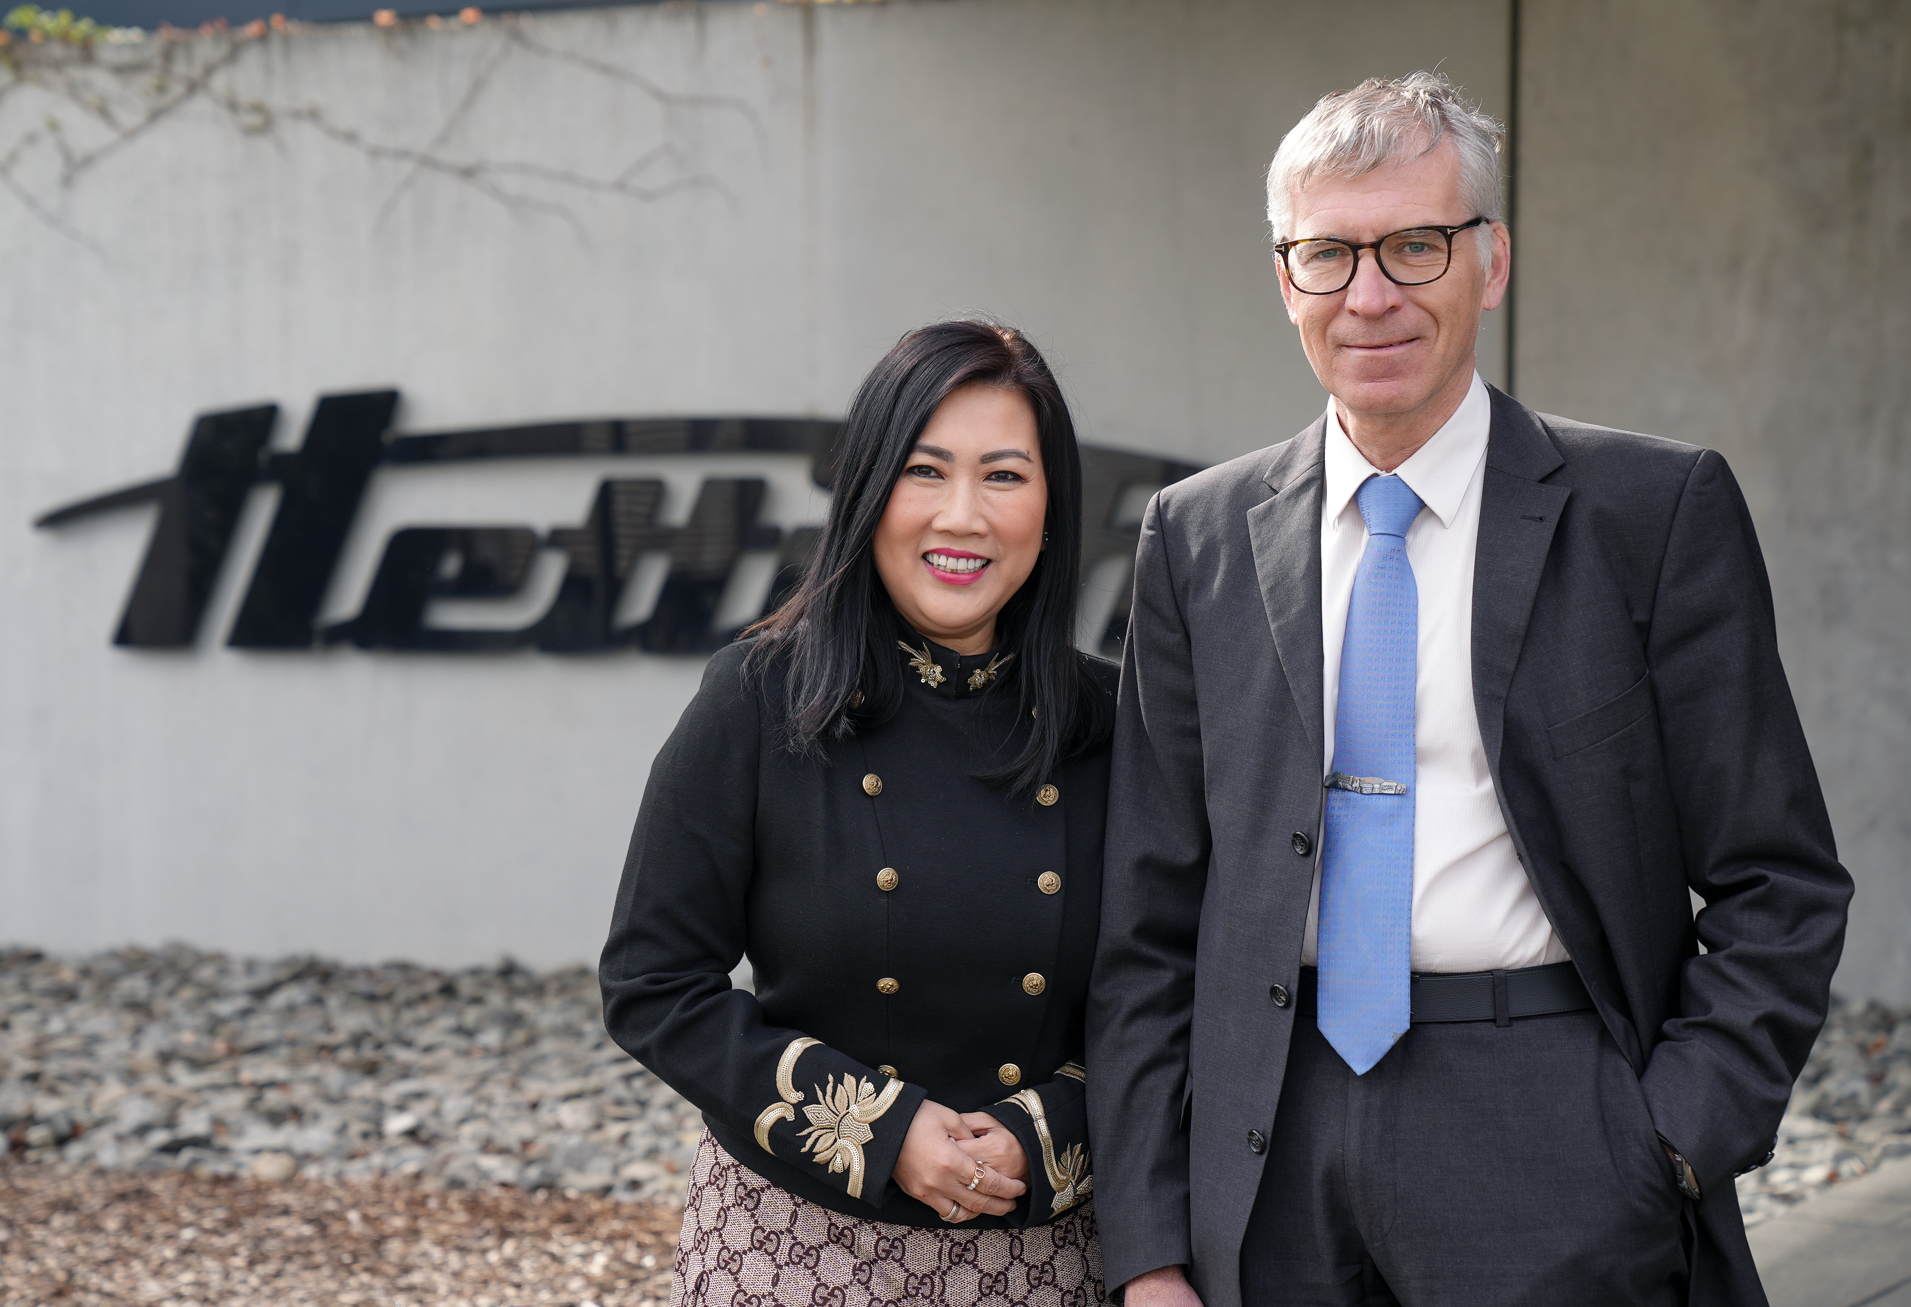

Picture: Kristina Eberle & Klaus-Günter Eberle – Handing over management responsibilities
and transitioning to advisory roles within the Hettich Group.

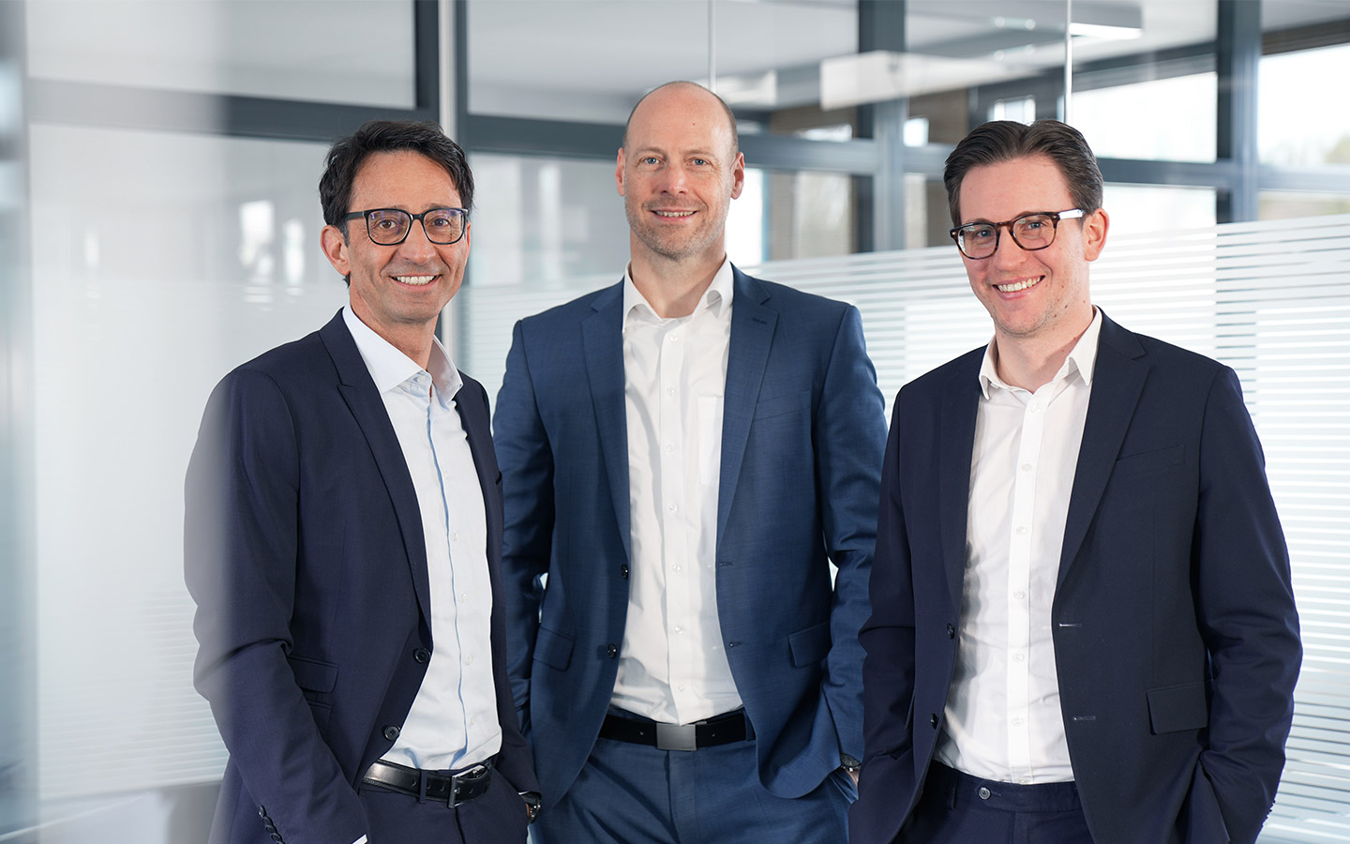

Image 2: (from left to right) Ralf Ledda, Christoph Pabst & Leopold Frank – The new leadership trio
guiding the Hettich Group into the future.

About Andreas Hettich GmbH
Andreas Hettich GmbH - is a leading global manufacturer of centrifuges and incubators, providing high-quality products for research labs, clinical labs, and medical facilities worldwide. With 120 years of experience and worldwide over 500 employees, Hettich is committed to developing innovative solutions that meet the evolving needs of the scientific community. All departments such as research, development and production are located at the headquarters in Tuttlingen, Germany.
Further information at www.hettichlab.com

